**CSA1143 – Object Oriented Analysis and Design**

***Name:*** Benny Steward S

***Register No:*** 192011033

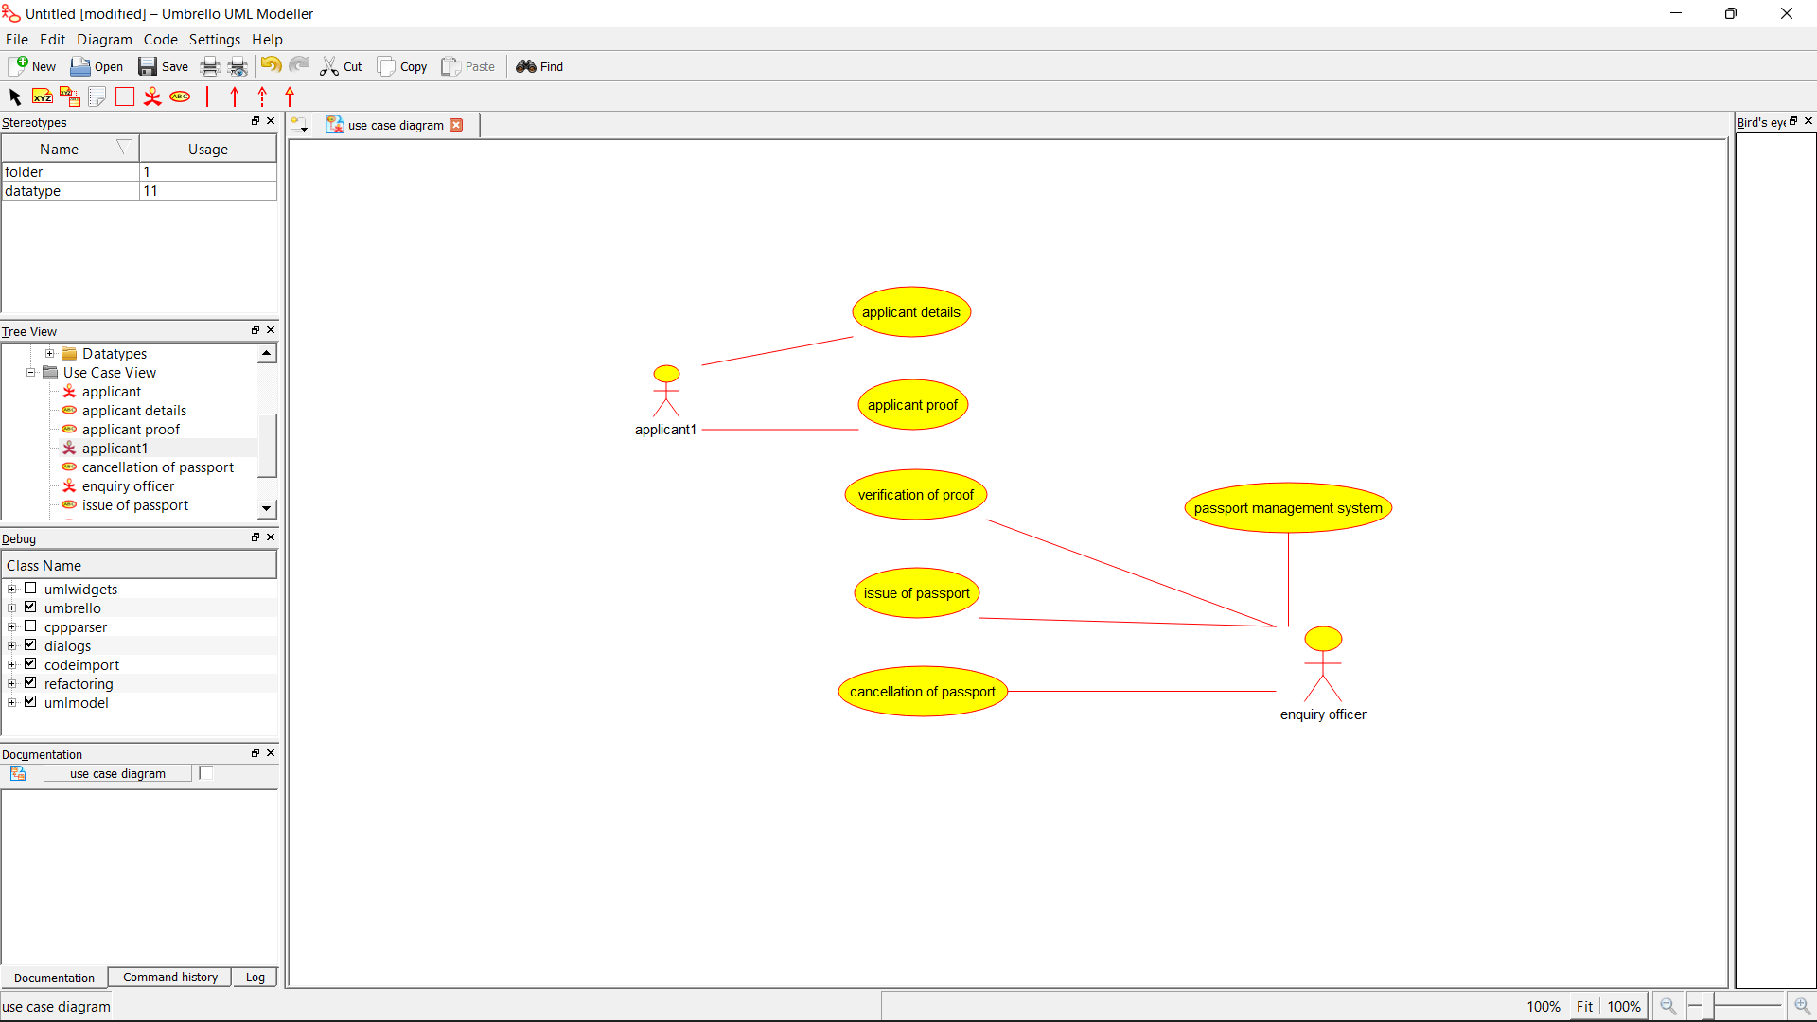

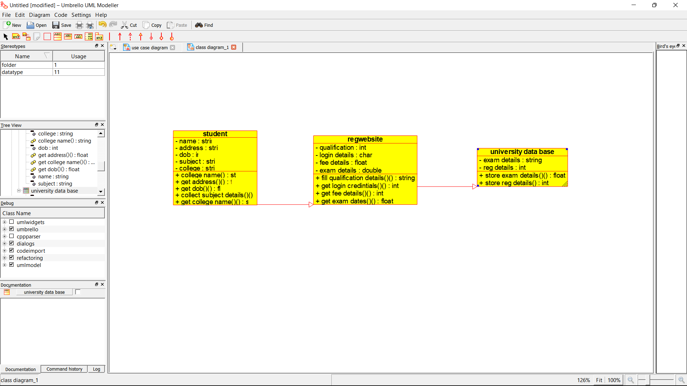

**Skeletal Code:**

/**

* Class university_database

*/

public class university_database {

//

// Fields

//

//

// Constructors

//

publicuniversity_database () { };

//

// Methods

//

//

// Accessor methods

//

//

// Other methods

//

}

/**

* Class regwebsite

*/

public class regwebsite extends university_data_base {

//

// Fields

//

privateint qualification;

private char login_details;

private float fee_details;

private double exam_details;

//

// Constructors

//

publicregwebsite () { };

//

// Methods

//

//

// Accessor methods

//

/**

* Set the value of qualification

* @paramnewVar the new value of qualification

*/

private void setQualification (intnewVar) {

qualification = newVar;

}

/**

* Get the value of qualification

* @return the value of qualification

*/

privateintgetQualification () {

return qualification;

}

/**

* Set the value of login_details

* @paramnewVar the new value of login_details

*/

private void setLogin_details (char newVar) {

login_details = newVar;

}

/**

* Get the value of login_details

* @return the value of login_details

*/

private char getLogin_details () {

returnlogin_details;

}

/**

* Set the value of fee_details

* @paramnewVar the new value of fee_details

*/

private void setFee_details (float newVar) {

fee_details = newVar;

}

/**

* Get the value of fee_details

* @return the value of fee_details

*/

private float getFee_details () {

returnfee_details;

}

/**

* Set the value of exam_details

* @paramnewVar the new value of exam_details

*/

private void setExam_details (double newVar) {

exam_details = newVar;

}

/**

* Get the value of exam_details

* @return the value of exam_details

*/

private double getExam_details () {

returnexam_details;

}

//

// Other methods

//

/**

* @return String

*/

public String fill_qualification_details_()

{

}

/**

* @return int

*/

publicintget_login_credintials_()

{

}

/**

* @return int

*/

publicintget_fee_details_()

{

}

/**

* @return float

*/

public float get_exam_dates_()

{